**Literature Review on distributed database system**

Before going on to Distributed Database Systems, let me briefly explain about Centralized Database Systems. Here all system components i.e the database and the Database Management System (DBMS) reside at a single computer or site. Users may be able to access the centralized Database System remotely via terminals connected to the site; however all the data access and processing takes place at the central site. The following figure shows a centralized DB System.

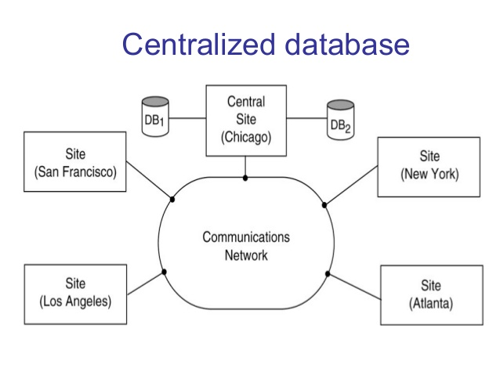

Figure(c) Centralized Database with different sites

Distributed database management system (DDBMS) In a DDS, database applications running at any of the system's sites should be able to operate on any of the database fragments transparently i.e., as if the data come from a single database managed by one DBMS. The software that manages a distributed database in such a way is called DDBMS.

The notion of distributed database is different from that of decentralised database. The latter does not imply sharing of data by a communication network. The former implies a collection of sites connected together with some kind of network and where each site has a database in its own right, but the sites work together as if data was stored at only one site.(Potocki 2017)

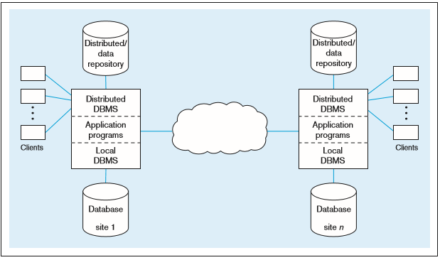 Figure(b) Distributed Database System

The communication network is used for information exchange, interaction and co-ordination among the various processes. Some systems are a library of routines intended at communication between hosts,while other systems link the various hosts tighter such that the application sees only one system. These two cases are called loosely and tightly coupledistributed systems respectively.

References

1. Concurrency control in a system for distributed databases (SDD-1). (n.d.). Retrieved April 06, 2017, from <http://dl.acm.org/citation.cfm?doid=320128.320131>
2. Shanker, U., Misra, M., & Sarje, A. K. (2008, January 26). Distributed real time database systems: background and literature review. Retrieved April 06, 2017, from https://link.springer.com/article/10.1007/s10619-008-7024-5